LockedIn – Collaborative Peer Learning & Study Accountability Platform

Abstract

LockedIn is a full-stack collaborative peer-learning and study accountability platform designed to help students find the right peers for learning and teaching. It uses skill-based matching to connect students based on complementary subjects, proficiency levels, and learning goals, while supporting both tutor-led and co-study sessions. Each study group provides a shared syllabus with individual progress tracking, a doubt-solving board, live sessions, document sharing, and an automatically compiled knowledge wiki from session notes. To encourage participation without excluding beginners, LockedIn uses a hybrid credit system that provides free weekly credits while rewarding teaching, doubt answering, co-study, and contributions. Additional features such as availability-based scheduling, reminders, dual learner/teacher & learner leaderboards, ratings, and public teaching portfolios build accountability and trust. LockedIn transforms informal peer learning into a structured, collaborative, and sustainable learning ecosystem.

Core Features

1. Skill-Based Matching
2. Shared Syllabus, Individual Progress Tracking
3. Flexible Live Sessions (Tutor-Led or Co-Study)
4. Hybrid Credit Economy
5. Doubt/Q&A Board per Study Group
6. Session Notes → Auto-Compiled Group Wiki
7. Dual Leaderboards
8. Public Teaching Portfolio & Trust Score
9. Availability-Based Scheduling

Technology Stack

Layer | Technologies
Backend | Spring Boot, Spring Security (JWT, college-email restricted signup), Spring Data JPA, MySQL / PostgreSQL
Frontend | React (Vite), Axios, React Router DOM, Context API
Real-time layer | WebRTC / Jitsi SDK for video-audio sessions, WebSockets for live doubt board and progress updates
Extras | Recharts (progress dashboards), Spring Mail (reminders), Spring @Scheduled (weekly credit top-up job), Cloudinary / S3 (document & wiki file storage)

Frontend Workflow:

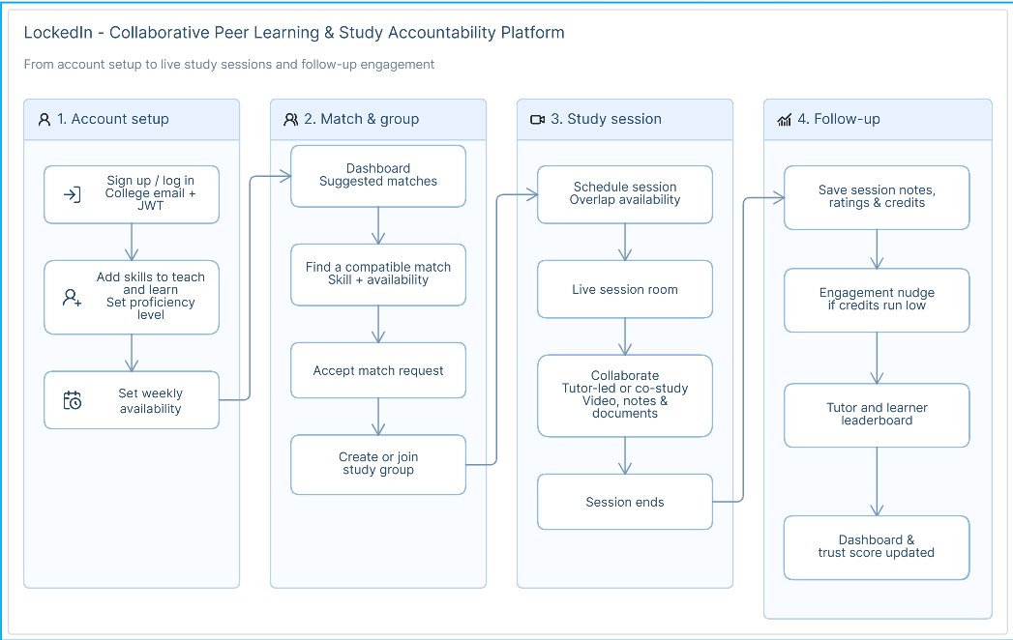

Backend Workflow:

